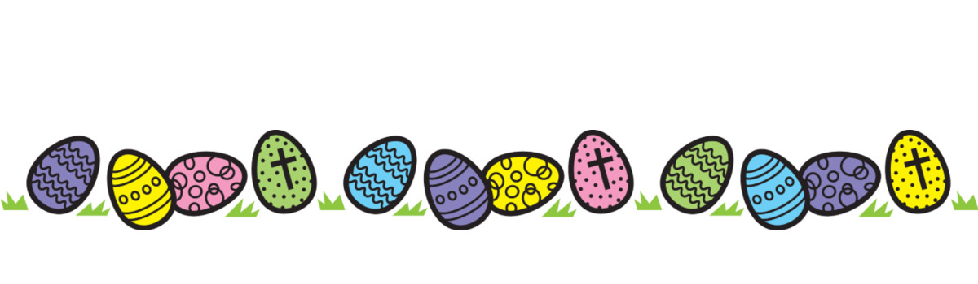

**$1 for a guess in both jars.**

**Closest to the number wins the jar**

**There is a small jar and a big Jar to be won!**

**Drawn Thursday 11/4/2019**

**Guess the number of eggs in the jars**